# Multi-agent safe invariant set.

Huaiyuan Teng

## Background

There are many smart agents $\{A_{1},A_{2}, A_{3}…A_{n}\}$ living in a shared space. Each agent is capable of controlling its own behavior by:

${\dot{x}}_{i}=f_{i}(x_{i}, u_{i})$ (1.1)

For easier representation, also define its integration:

$F_{i}\left(x, u, t\right)≜ state after controling x using u for time t$ (1.2)

For each two of them, certain pair of state is dangerous, known as crush. We use the following Boolean function to denote that:

$Crush_{i}^{j}\left(x_{i}, x_{j}\right)$ (1.3)

Agents are not capable of communicating with each other. However, they can observe the state of any agent in the system.

Given such a system, this article is proposing a strategy for those agents to peacefully live in the space, by applying control supervisor based on safe invariant set.

For each agent, its control $u_{i}$ is limited by supervision set $R_{i}$:

$u_{i}∈R_{i}(x_{1}, x_{2}, …x_{n})$ (1.4)

In the following pages, the word “regulation” will be used to represent such supervision set.

## Principle 1. Non-correlated regulation (NCR)

The author thinks that one agent is never capable of considering all the other agents in a correlated manner at real time. The computational power of a single agent is limited, such that it can only regulate its behavior using following form:

$R_{i}\left(x_{1}, x_{2}, …x_{n}\right)= ∩_{j=0, j≠i}^{n}R_{i}^{j}\left(x_{i}, x_{j}\right)$ (2.1)

First, for each other agent $A_{j}$, $A_{i}$ works out a two-body regulation $R_{i}^{j}$ considering only the states of $A_{j}$ and $A_{i}$. Then $A_{i}$ chooses its final regulation to be the intersection of all such two body regulations.

## Principle 2. Basic agent right.

There can be many different results of $R_{i}^{j}$ considering the abundance of the agents. No matter what they are, the intersection of them in eq (2.1) cannot be empty, or otherwise there would be no choice for $A_{i}$ to make.

In fact, each other agent may cast certain regulation upon $A_{i}$, but they are not clever enough to think in $A_{i}$’s perspective. To achieve the non-emptiness of $A_{i}$’s final regulation, one solution is to make the contract of “basic agent right”:

For each agent $A_{i}$, there exist a control known as the “basic agent right”, denoted as $b_{i}$. $A_{i}$ shall be always allowed to take $u_{i}∈B_{i}(x_{i})$ as its next control. On the other hand, $A_{i}$’s control needs to be regulated such that it won’t harm the basic right of any other agents. ( $B_{i}$ can be estimated by all agents.)

In the later pages, we will show that the peaceful space can be achieved if every NCR agent observes the principle of basic agent right.

## Notion of backup safety.

Given the fact that $A_{i}$’s control is regulated by certain strategy $B_{i}(x_{i})$, there would be an obtainable forward reachable set:

$FR_{i}\left(B_{i}, x_{i}, t\right)≜\left\{x_{f}\right| A_{i} keep use u_{i}∈B_{i}\left(x\right), and can reach x_{f} at time t\}$ (3.1)

Here the strict definition is not given, since there would be a lot of words.

We further define the collision of two forward reachable set:

$${Crush}_{i}^{j}\left(x_{i}, x_{j}, B_{i},B_{j}\right)=∃ t≥0, s.t.$$

$∃ x_{i}^{c}∈FR_{i}\left(B_{i}, x_{i}, t\right), x_{j}^{c}∈FR_{j}\left(B_{j}, x_{j}, t\right), Crush_{i}^{j}(x_{i}^{c}, x_{j}^{c})$ (3.2)

The straight forward understanding of eq (3.2) is: if $A_{i}$ follow strategy of $B_{i}$ and $A_{j}$ follow strategy of $B_{j}$, whether it is possible for a future crush to happen.

For some two agents $A_{i}$, $A_{j}$ in the n-agent system, by instinct one necessary condition for “eventually no crush between $A_{i}$ and $A_{j}$ for all possible trajectories starting from $x_{i}, x_{j}$” is “backup safety”:

${BS}_{j}^{i}\left(x_{j}, x_{i}\right)={BS}_{i}^{j}\left(x_{i}, x_{j}\right)≜{!Crush}_{i}^{j}\left(x_{i}, x_{j}, B_{i},B_{j}\right)$ (3.3)

Instinct of necessity: since there are many other agents in the space, it is possible that $A_{i}$‘s final regulation set get maximumly squeezed by other agents, such that $∀t>0$, $A_{i}$ has nothing to do but to take the backup choice from $B_{i}$. The same goes for $A_{j}$. If such situation happens (such situation can always happen no matter how the agents are regulated), eq (3.3) is equivalent to the definition of “eventually no crush between $A_{i}$ and $A_{j}$, starting from $x_{i}, x_{j}$”. (Elements in $B$ are not allowed to be further regulated according to the description of “basic right”)

So the guidance of the design is that eq (3.3) must hold true for all selection of $i,j$ to avoid the risk of collision.

## Notion of moral bottom line

To avoid a complicated story, we further limit the dynamic to discrete time axis.

${x_{i}\left(k+1\right)= F}_{i}\left(x_{i}(k), u_{i}(k), dt\right)$ (4.1)

As mention before, $A_{i}$, $A_{j}$ must try to keep eq (5) all the time since from their perspective doing so is necessary for collision prevention.

Suppose ${BS}_{i}^{j}\left(x_{i}(k), x_{j}(k)\right)=true$ at moment $k$. To keep such property at $k+1$, $A_{j}$ must satisfy:

$R_{j}^{i}\left(x_{j}, x_{i}\right)⊆M_{j}^{i}\left(x_{j}, x_{i}\right)≜\{u_{j}|∀u_{i}∈B_{i}\left(x_{i}\right), {BS}_{i}^{j}\left(F_{i}\left(x_{i}, u_{i}, dt\right), F_{j}\left(x_{j}, u_{j}, dt\right)\right)\}$ (4.2)

From the principle 2 basic agent right, $A_{j}$ must respect the basic right of $A_{i}$. It is possible for $A_{i}$ to choose $b_{i}$ at $k$, thus $A_{j}$ must constraint its action in $M_{j}(x_{j}, x_{i})$ so as to avoid potential backup safe regression. The constraint of $M_{j}^{i}$, known as $A_{j}$’s moral bottom line over $A_{i}$, must also be enforced to everyone in the space to rule out the risk of collision.

${BS}_{i}^{j}\left(x_{i}, x_{j}\right)→M_{j}^{i}\left(x_{j}, x_{i}\right)≠∅$ (4.3)

Proof of eq (4.3): by showing $B_{j}(x_{j})$ is subset of $M_{j}^{i}\left(x_{j}, x_{i}\right)$.

## First order freedom

Knowing that each agent is at least regulated by moral bottom line, there is one design of regulation set that can be sufficient for the purpose of peaceful living:

$R_{i}^{j}\left(x_{i}, x_{j}\right)≜\left\{u_{i}\right| ∀u_{j}∈$ $M_{j}^{i}\left(x_{j}, x_{i}\right)$, ${BS}_{i}^{j}\left(F_{i}\left(x_{i}, u_{i}, dt\right), F_{j}\left(x_{j}, u_{j}, dt\right)\right) \}$ (5.1)

It is not hard to prove that:

$B_{i}\left(x_{i}\right)⊆R_{i}^{j}\left(x_{i}, x_{j}\right)⊆M_{i}^{j}\left(x_{i}, x_{j}\right)$ (5.2)

So here such regulation $R_{i}^{j}$ observes moral bottom line, while also protects $A_{i}$’s own basic right.

When $A_{i}$ regulates its control $u_{i}∈R_{i}^{j}\left(x_{i}, x_{j}\right)$ defined by (5.1) and $A_{j}$ observes (4.2), it can be proved that for any step $k$:

${BS}_{i}^{j}\left(x_{i}(k), x_{j}(k)\right)→ {BS}_{i}^{j}\left(x_{i}(k+1), x_{j}(k+1)\right)$ (5.3)

The backup safe invariance between $A_{i}$ and $A_{j}$ is then achieved.

$R_{i}\left(x_{1}, x_{2}, …x_{n}\right)$, as the intersection of $R_{i}^{j}$, is always respecting other’s basic right, while protecting $A_{i}$’s own basic right, using (5.2), and can be proved to be not empty if ${BS}_{i}^{j}\left(x_{i}, x_{j}\right)$. Together with (5.3), the design is done.

## Multiple possibilities of basic right

In practice, it is hard for one to tell the basic right of an unfamiliar agent. For $A_{i}$ the choice of $B_{j}$ varies, depending upon the background of $A_{j}$, or culture, ideology… However, the existence and unique-ness of $B_{j}$ still stands. $A_{i}$ may anticipate a list of possibilities for $B_{j}∈G_{j}^{i}=\{B_{j}^{i1}, B_{j}^{i2},….B_{j}^{im}\}$, while not knowing what exactly $B_{j}$ is.

The moral bottom line becomes the intersection of enumerating through the other agent’s basic right list:

$M_{j}^{i}\left(B_{2}, B_{1},x_{j}, x_{i}\right)≜\{u_{j}|∀u_{i}∈B_{1}\left(x_{i}\right), {!Crush}_{i}^{j}\left(F_{i}\left(x_{i}, u_{i}, dt\right), F_{j}\left(x_{j}, u_{j}, dt\right), B_{1}, B_{2}\right)\}$ (6.1)

$R_{j}^{i}\left(x_{j}, x_{i}\right)⊆M_{j}^{i}\left(x_{j}, x_{i}\right)= ∩_{B_{1}∈G_{i}^{j}, \left(skip unsafe B_{1},B_{j}\right)} M_{j}^{i}\left(B_{j},B_{1}, x_{j}, x_{i}\right)$ (6.2)

Some anticipation $B_{1}$ can lead to empty result of $M_{j}^{i}\left(B_{j},B_{1}, x_{j}, x_{i}\right)$, which shall be skipped in the calculation of moral bottom line. ( $B_{1}$ can be ruled out by assuming the current situation is backup safe).

With $A_{j}$ observes (6.2), the action set of $A_{i}$ is then defined as:

$R_{i}^{j}\left(B, x_{i}, x_{j}\right)≜\left\{u_{i}\right| ∀u_{j}∈$ $M_{j}^{i}\left(B, B_{i},x_{j}, x_{i}\right)$, ${!Crush}_{i}^{j}\left(F_{i}\left(x_{i}, u_{i}, dt\right), F_{j}\left(x_{j}, u_{j}, dt\right), B_{i}, B\right) \}$ (6.3)

$R_{i}^{j}\left(x_{i}, x_{j}\right)≜∩_{B∈G_{j}^{i}, \left(skip unsafe B_{i}, B\right)}R_{i}^{j}\left(B, x_{i}, x_{j}\right)$ (6.4)

It is not hard to show that basic right is protected:

$$B_{i}\left(x_{i}\right)⊆R_{i}^{j}\left(x_{i}, x_{j}\right)$$

For the observation of moral bottom line:

$R_{i}^{j}\left(x_{i}, x_{j}\right)⊆ M_{i}^{j}\left(x_{i}, x_{j}\right)$

For each single enumeration of $B$, $R_{i}^{j}\left(B, x_{i}, x_{j}\right)⊆ M_{i}^{j}\left(B_{i}, B,x_{i}, x_{j}\right)$ can be proved. The intersection operation will simply keep that property.

If $B_{j}∈G_{j}^{i}$ and $B_{i}∈G_{i}^{j}$, we have:

$R_{i}^{j}\left(x_{i}, x_{j}\right)⊆R_{i}^{j}\left(B_{j}, x_{i}, x_{j}\right)$

$M_{j}^{i}\left(x_{j}, x_{i}\right)⊆M_{j}^{i}\left(B_{j}, B_{i},x_{j}, x_{i}\right)$

The safe invariance property in eq (5.3) can be proved.

## General right system and right graph analysis.

In practice, the right of an agent $A_{i}$ is normally more than what is referred as the “basic right” $B_{i}$. Generally speaking, the right of an agent grows as it levels up in social status. We use a double parameter $b_{i}$ to represent the right level of an agent: $u_{i}∈K_{i}\left(b_{i}, x_{i}\right)$ is always allowed when $A_{i}$‘s right level equals $b_{i}$ (and $u_{i}∉K_{i}\left(b_{i}, x_{i}\right)$ is not always allowed). $K_{i}$ is monotonically non-decreasing over $b$ input:

$∀i,x_{i}, b_{1}<b_{2}→K_{i}\left(b_{1}, x_{i}\right)⊆ K_{i}\left(b_{2}, x_{i}\right)$ (7.1)

Given the right level and state of $A_{i}$ and $A_{j}$, the invariance item is defined as:

$I_{j}^{i}\left(b_{j},b_{i}{,x}_{j},x_{i}\right)=I_{i}^{j}\left(b_{i},b_{j},x_{i},x_{j}\right) ≜ {!Crush}_{i}^{j}\left(x_{i}, x_{j}, K_{i}\left(b_{i},x_{i}\right),K_{j}(b_{j},x_{j})\right)$ (7.2)

known as the **invariance indicator function**. For the same states, a point $(b_{i}, b_{j})$ is invariant true indicates its left bottom side region is invariant true:

$∀b_{1}≤ b_{i},∀b_{2}≤b_{j}, I_{i}^{j}\left(x_{i},x_{j},b_{i},b_{j}\right)→I_{i}^{j}\left(x_{i},x_{j},b_{1},b_{2}\right)$ (7.3)

Take the crossing problem in autonomous driving as example, let $b_{i}, b_{j}$ be the max acceleration of the vehicles:

$K_{i}\left(b_{2}, x_{i}\right)=\left\{u_{i}\right|u_{i}.acc<b_{2}\}$ (7.4)

And place their states at the deep-colored boxes with certain initial speed in figure (7.1). Their invariance chart would be like that shown on the left side of figure (7.1).

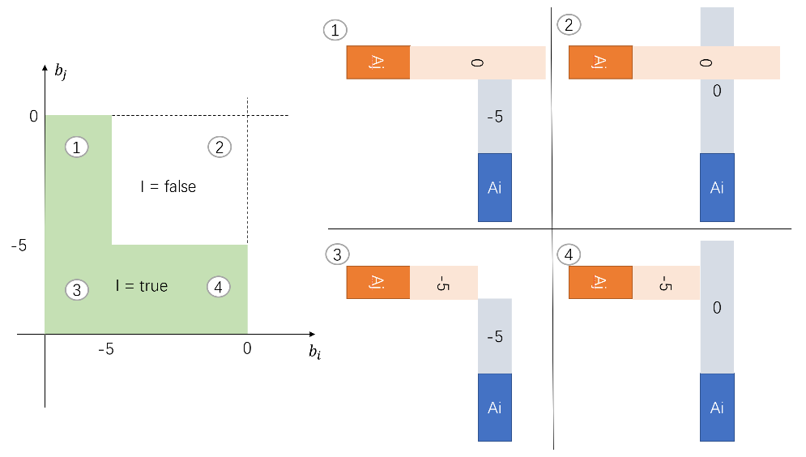

Figure 7.1. Crossing Problem Invariance chart.

Explanation: There are 4 typical cases:

1. $b_{j}$ is at keep running, $b_{i}$ is at braking. ($b_{j}=0$, $b_{i}=-5$)
2. $b_{j}$ is at keep running, $b_{i}$ is at keep running. ($b_{j}=0$, $b_{i}=0$)
3. $b_{j}$ is at braking, $b_{i}$ is at braking. ($b_{j}=-5$, $b_{i}=-5$)
4. $b_{j}$ is at braking, $b_{i}$ is at keep running. ($b_{j}=-5$, $b_{i}=0$)

1,3 and 4 are invariant true and 2 is invariant false. If both vehicles are always allowed to keep running, they would possibly collide.

The invariance indicator graph generally says, int the current situation there is no way such that both vehicles can enjoy the right of “keep running”. To the contrast, either to let $A_{i}$ yield and keep $A_{j}$’s keeping running right, or to let $A_{j}$ yield and keep $A_{i}$’s keeping running right are acceptable invariance plans. The final result of each agent right is jointly decided by both agents.

We define the **moral function** of as follows:

$M_{i}^{j}\left(b_{i},b_{j},x_{i},x_{j}\right)≜ \{u_{i}|∀u_{j}∈K_{j}\left(b_{j},x_{j}\right), I_{i}^{j}\left(b_{i},b_{j},F_{i}\left(x_{i}, u_{i}, dt\right), F_{j}\left(x_{j}, u_{j}, dt\right)\right)\}$ (7.5)

If $A_{i}$‘s next step action $u_{i}$ is inside $M_{i}^{j}\left(b_{i},b_{j},x_{i},x_{j}\right)$, we say $A_{i}$ guards the morality of ${ (b}_{i},b_{j})$. The physical meaning of $u_{i}$ guarding ${ (b}_{i},b_{j})$ is that, if $A_{j}$ choose to exercise its right $u_{j}∈K_{j}\left(b_{j},x_{j}\right)$, the invariance of ${ (b}_{i},b_{j})$ can be preserved from current frame to next frame. (Invariant true indicates moral function is non-empty for ${ (b}_{i},b_{j})$). It is not hard to show that:

$u_{i}∈M_{i}^{j}\left(b_{i},b_{j},x_{i},x_{j}\right)→u_{i}∈M_{i}^{j}\left(b_{1},b_{2},x_{i},x_{j}\right) , ∀b_{1}<b_{i}, b_{2}<b_{j}$ (7.6)

The monotonicity of eq (7.6) and eq (7.3) indicates that we can describe the set of invariance and moral using a border function:

$D{M_{i}^{j}}_{\left\{x_{i},x_{j}\right\}}\left(u_{i}, b_{i}\right)≜\max\left(b_{j}\right) subject to u_{i}∈M_{i}^{j}\left(b_{i},b_{j},x_{i},x_{j}\right)$

$D{I_{i}^{j}}_{\left\{x_{i},x_{j}\right\}}\left( b_{i}\right)≜\max\left(b_{j}\right) subject to I_{i}^{j}\left(b_{i},b_{j},x_{i},x_{j}\right)$

Known as the invariance border and moral border.

Still using the crossing problem as example, the two border functions are displayed in figure (7.2)

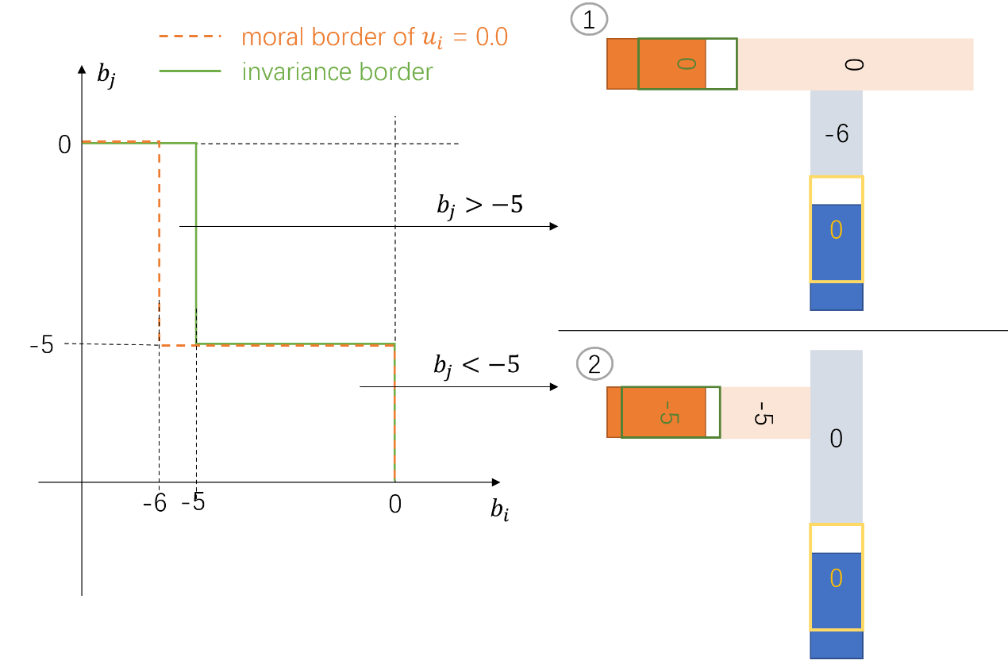

Figure 7.2 Border function of moral and invariance.

Explanation: The invariance border function (in green solid line) is simply the boundary of the invariant true region in figure (7.1). The moral border function of $A_{i}$, taking $u_{i}=0$ as example, is displayed in orange dashed line in figure (7.2). Generally speaking, there are two conditions after $A_{i}$ chooses $u_{i}=0$:

1. If the invariance plan allows $b_{j}> -5$, as shown by the top right, the old invariance region of case 1 in figure (7.1) would be squeezed, since after keep running ($u_{i}=0$) for a while, $A_{i}$ would have to brake more than -5 to keep the invariance true.
2. If the invariance plan does not allow $b_{j}> -5$, as shown by the bottom right, there won’t be anything bad to come since $u_{i}=0$ is always allowed by the invariance plan for $A_{i}$.

$A_{j}$ is required to observe certain moral bottom line, such that for the basic right level $b_{j}^{0},b_{i}^{0}$, the control $u_{j}$ must guard it. Using this fact, the **freedom function** and its border function is defined as follows:

$$R_{i}^{j}\left(b_{i}^{0}, b_{j}^{0},b_{i},b_{j},x_{i},x_{j}\right)≜ \{u_{i}|∀u_{j}∈M_{j}^{i}\left(b_{j}^{0},b_{i}^{0},x_{j},x_{i}\right), I_{i}^{j}\left(b_{i},b_{j},F_{i}\left(x_{i}, u_{i}, dt\right), F_{j}\left(x_{j}, u_{j}, dt\right)\right)\}$$

$D{R_{i}^{j}}_{\left\{b_{i}^{0}, b_{j}^{0}, x_{i},x_{j}\right\}}\left(u_{i}, b_{i}\right)≜\max\left(b_{j}\right) subject to u_{i}∈R_{i}^{j}\left(b_{i}^{0}, b_{j}^{0},b_{i},b_{j},x_{i},x_{j}\right)$

(注意 R 不一定 小于 M, 最小和谐度最大理论也有问题: 对于已经发生的不和谐无能为力呢? 行人撞尾)。 当然， 我们可以设法改变物体位姿使得basic 位点I true, 从而严格控制R < M.

## Extension of basic right: rights as if it is basic

It is however, possible that an agent gets wandering in its mind, without noticing certain situation that could be dangerous. The basic right of being absent minded is not desirable yet always unavoidable.

In some cases, there are agents that must be treated as if they have outstandingly many basic rights. For example, in the un-protected left turn it is pretty much a good idea that the left turn vehicle assumes all going straight vehicles are unstoppable. A going straight vehicle has all the braking actions as its basic right, including a “non-decelerating” one.

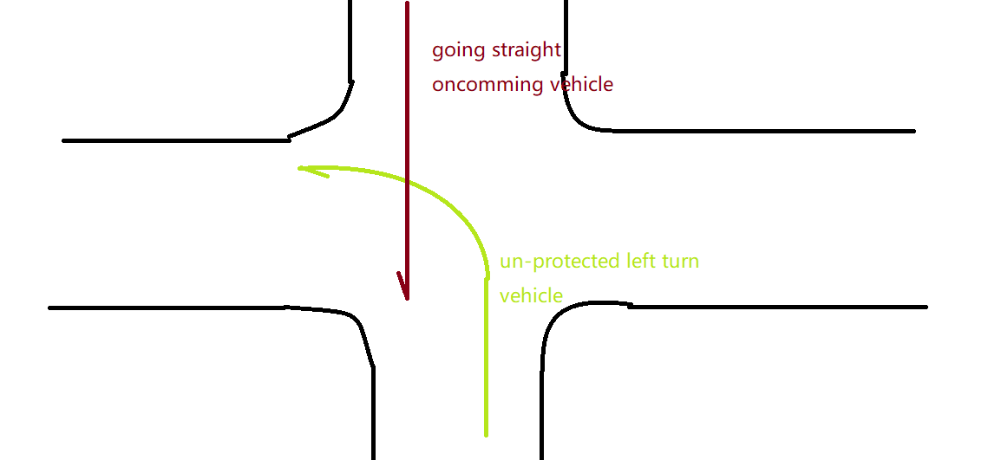

However, if a left turning vehicle do stopped in front of the going straight one, and it seems that the only way to achieve safe ending is to have the going straight vehicle give up its “basic right” of non-decelerating motion. In most cases the going straight vehicle shall do so.

权利池: 直行车: 我可以以此为假设去要求对方， 但是一旦我清楚的知道对方做不到， 我也会心软的自我裁剪权利。 即 “skip unsafe ones” 这件事的本质.

你可以计算这一帧， 各种权利的成立概率， 但是：

1. 真的只有一个才是 Br 吗？ 和为1 吗?
2. 下一步开花后的概率很多， 很复杂， 难以计算所谓最佳action

不妨改成这一帧， 先过渡到各种A2 action的概率? 以及相应action 对应的权利守护类型.

这样我们的action是否构成侵权，在每种可能下也能容易阐明.

The probability for a right to be “in need of protection”. The power of right function:

（the function is in $A_{i}$’s sense）

$$P_{R\{i,j\}} :G_{j}^{i}→ R$$

Some rules here for the property of power of right:

1, If $A_{i}$ deems $B∈G_{j}^{i}$ as $A_{j}$‘s basic right, $P_{R\left\{i,j\right\}}\left(B\right)=1.0$.

2, If $A_{i}$ find that $A_{j}$ might not see $A_{i}$, then for any strategy, $P_{R\left\{i,j\right\}}\left(B\right)>0$.

For example, a going straight vehicle may have the right to protect its non-decelerating action $B_{n}$, yet in the perspective of the left turn vehicle, such a right might have already been violated by the fact that there is a slow front vehicle in front of the going straight vehicle. The probability that $B_{n}$ shall be respected is not always 1.0.

For each $u_{j}$, define the protection function over $A_{j}$‘s right $B_{2}$, with assuming $A_{i}$’s basic right is $B_{1}$. （the function is in common sense）

$Prot_{j}^{i}\left(u_{j}, B_{2},B_{1}\right)= ∀b_{i}∈B_{1}\left(x_{i}\right), {!Crush}_{i}^{j}\left(F_{i}\left(x_{i}, b_{i}, dt\right), F_{j}\left(x_{j}, u_{j}, dt\right), B_{1}, B_{2}\right)$

$$Pro{tList}_{j}^{i}\left(u_{j}, B_{1}\right)=\{B_{2}|Prot_{j}^{i}\left(u_{j}, B_{2},B_{1}\right)\}$$

We now try to determine the distribution of $u_{j}$ being self-restricted by $A_{j}$ using protection list and the combined distribution of $P_{R\{i,j\}}$. With assuming $A_{j}$’s moral level is at protecting $A_{i}$’s $B_{1}$.

用通道概率描述法 $B_{1}$ 取一些可能（均包含 $B_{i}$？），每种通道下的 in need of protection 真值是有的。Mj 是有的.

对于每个通道, Mj 能否保全一个非空的，指向更舒适 $B_{1}$ 的 $R_{i}^{j}$？

或者这么问: $A_{i}$ action选择一个缓刹车，有多大概率能够在不侵犯反对方守护的前提下， 下一帧实现 缓刹车的 BS?

~~此时， 站在 B1 上， 有必要协助维护所有可能 Mj 所祈求的保护。 所以选取一个Ri~~

~~站在 B1 更大集合上，Ri 内部会有一些action, 可以使得大部分高概率 Mj 情况下， 站在B2上的 invariance 得以幸存.(即，B2 & in need of protection 做结果， Mj 不变来定义单元 $R_{i}^{j}$)，则这部分action 是更加desirable的:~~